Executive Summary

Analysis Of Olympics

[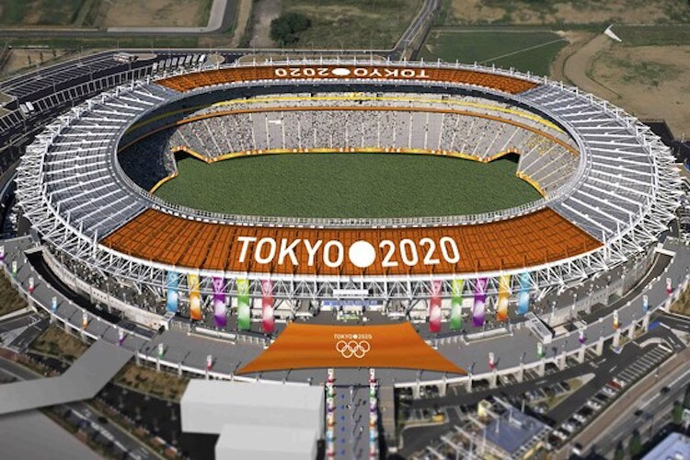](https://www.google.com/url?sa=i&rct=j&q=&esrc=s&source=images&cd=&cad=rja&uact=8&ved=2ahUKEwixmY_py8HdAhWHpo8KHc_zD_cQjRx6BAgBEAU&url=http://jpninfo.com/19453&psig=AOvVaw1nvqWhEdi2xcpH7AzT0hVL&ust=1537258333032009)

Table of Contents

* Executive Summary……………………………………………………………………………….
* Business Problem…………………………………………………………………………………..
* Introduction…………………………………………………………………………………..
* Motivation For Study…………………………………………………………………………………..
* Methodology & Tools…………………………………………………………………………………..
* Models…………………………………………………………………………………..
* Message…………………………………………………………………………………..
* Means…………………………………………………………………………………..
* Analytics Approach…………………………………………………………………………………..
* Connecting CBA Term – 2 courses…………………………………………………………………………………..
* Data collection & cleaning…………………………………………………………………………………..
* Data Preparation…………………………………………………………………………………..
* Analysis & Results…………………………………………………………………………………..
* Modelling & Evaluation…………………………………………………………………………………..
* Business Recommendation…………………………………………………………………………………..
* Assumptions, Limitations. …………………………………………………………………………………..
* References. …………………………………………………………………………………..

Executive Summary

There are two Olympics datasets that are used for creating the clusters and making a regression model to predict the total number of medals.

1. There exist a strong correlation between Olympics performance with Nominal GDP, Number of internet users, country is host or not.
2. Gender Gap index and Population of a country is correlated to some extent with the count of total medals.
3. Countries like US bag more medals in Swimming due to height of their players.
4. Nominal GDP is responsible for good performance of Russia , Australia, Germany, Great Britain and France in Olympics
5. China’s population and it’s sports culture, sports schools, sports trainees are responsible for it’s good performance.